**COSC 617-Advanced Web Development**

**Group 4 - Software Management Plan**

**Done By :**

**Vishal Patel**

**Manoja Koneru**

**Vijayashree Chodavaram**

**Kamshika Navya Sri Gundaram**

**Pravallika Karidi**

**Rangarajan KK**

**Table Of Contents**

|  |  |
| --- | --- |
| **Title** | **Page No** |
| Introduction | 3 |
| Objective | 4 |
| Background | 4 |
| Business risks | 4 |
| Functional Requirements | 5 |
| Non-Functional Requirements | 6 |
| Feasibility Analysis | 7 |
| Technical Feasibility | 7 |
| Organizational Feasibility | 8 |
| Economic Feasibility | 8,9 |
| Software Process | 10 |
| Justification of Software Process | 10 |
| Gantt Chart | 11 |
| Work breakdown Structure | 12 |
| Change Management Plan | 13 |

**Introduction**

This document serves as the project plan for developing games and promoting the developed games through an online portal to children . The content of this document is divided into the following sections: Objective , Requirements , Software process, Justification for the selection of the Software Process, Gantt Chart , Work Breakdown Structure and Change Management Plan.

The Objective section describes what the company is trying to achieve by building this product. It provides an overview of the application and describes the scope and limitations of the development effort.

The requirements section describes the functional and non functional requirements.

The Software process section describes the methodology used for building this application and the justification for the software process section describes why this particular methodology is being chosen for building this project.

The feasibility analysis describes the technical feasibility, organizational feasibility and economic feasibility.

The Gantt chart describes the tasks that need to be completed. It demonstrates the duration in terms of bars and the top of the Gantt chart has a scale which indicates the number of weeks and the tasks are listed on the left.

The Work Breakdown structure, as the name indicates consists of how the tasks are being broken down. The tasks are divided into Requirements Gathering and Analysis, Design , implementation, testing and Project Closure.

**Objective:**

The main objective of this project is to build to a stimulating website to respond to the need for “Request for Information”. The website focuses on managing and promoting online games for children under the age 18. The games are designed with an objective to keep the children off the streets and

**Background**:

Top Tech Gaming Solutions is a medium sized technology company headquartered in Washington D.C. The company has decided to respond to a Request for information that was recently released by a local, anonymous philanthropist to create a “stimulating” website dedicated to managing and promoting online games for children under eighteen.  This philanthropist has first-hand experience in gaming, and, on a more personal note, has stated that “…access to gaming platforms during their youth kept them off the streets and out of trouble…”.

**Business Risks:**

Failure to complete the development of the website will limit the access for children from playing online games. So, if less children play the games this will limit the production of new games with exciting features and ideally the profit starts to decline. If the game is updated, the device should be compatible enough to support those upgrades to make sure that there exists no lag while the user is playing the game. If the interfaces are compatible with each other the cost to  maintain these interfaces to ensure that the game is working properly would be really high.

**Functional Requirements:**

The functional requirements below show all of the basic requirements that the Website must be able to perform and information that the system must contain.

|  |  |
| --- | --- |
| **Req #** | **Functional Requirement Statement** |
| FR1 | The site must provide access to games for children under eighteen with verification of age. |
| FR2 | Once a child turns eighteen, they have the option to pay for a subscription to the site |
| FR3 | The site must provide a way for parents to see what games their kids have played. |
| FR4 | The site must provide a way to track popular games (i.e.” top” performers). |
| FR5 | The site must accept monetary donations and support advertising from appropriate vendors to fund support of the site and development of new games. |
| FR6 | Ads must not “overrun” the site. |
| FR7 | Integrate with popular social media platforms |
| FR8 | A centralized leaderboard displaying top scores |
| FR9 | A technical review & status report roughly half-way through the project with semi-working prototype and/or mockups |
| FR10 | A final product review & prototype demo in the May 2019.  The winning design will be selected at this time. |

**Non-functional Requirements:**

The non-functional requirements below relate to the behavior of the system and focus on usability, security, and performance.

|  |  |
| --- | --- |
| **Req#** | **Non-Functional Requirement Statement** |
| NFR1 | The website will be able to differentiate parents and children |
| NFR2 | The game will be available for 24hrs a day, 365 days a year |
| NFR3 | The website will be compatible with windows (minimum Window XP) |
| NFR4 | The website will have a response time of 3 seconds |
| NFR5 | The website will enforce a password policy |
| NFR6 | The website will go through bi-weekly maintenance |
| NFR7 | The website will provide easy navigation |

**Feasibility Analysis**

A feasibility study is an analysis used in measuring the ability and likelihood to complete a project successfully including all relevant factors.  Feasibility analysis consists of three types: Technical Feasibility, Economic feasibility and Organizational feasibility.

**Technical Feasibility:**

Top Tech Gaming Solution’s project is Technically feasible but has some risks associated with it.

Top Tech Gaming Solution’s risk regarding familiarity with the technology is low.

* The IT department gives instructions on what programs to written for building a website to the programmers.
* Architects, system analysts and website designers communicate and coordinate on how to build the website solution in order to attract the attention of the users.
* Strategic alignment is used which acts as fit between the various departments in order to ensure the successful completion of the website.

The Project size is considered as medium risk.

* The project team would consist of 10 or fewer people.
* The time frame to complete the project is ideal and is 5 months.
* There must be user involvement, since if children continue to show their participation by playing numerous games online, the sales would expand, and the project can remain competitive.

**Organizational Feasibility**

Top Tech Gaming Solutions is a medium-sized technological company headquartered at Washington D.C targeting children under the age of 18 to play games online through the aid of a website. The main focus of this website is providing an easier facility for children to play games online and to incorporate new games into the website. A leaderboard will be included to display the user’s high score. Rating is provided for each game which  keeps track of the games deployed on the website. A project champion will help promote the website. Additionally, management support will help making better decisions and complete the project on time. One challenge in terms of organizational feasibility is to promote the new system and incentivize customers to use it.

**Economic Feasibility**

Cost/Benefit analysis is the most frequently method used in economic analysis. After comparing the costs and benefits, according the economic feasibility, we will determine whether the project is a good investment or a worse investment for the organization. If the benefits outweigh the costs, the project is a good investment. Otherwise, the project will be rejected or needs to be improved. To analyze economic feasibility for a gaming website for children , we will use the cost/benefit analysis from the following four components:

1) **Development cost** - Includes the expense to build the online system, including the website design team salary, the expense of building the necessary hardware and software, and the expense of database management and stability.

2) **Annual operating cost** - which includes the operations employee salaries, the expense of operating software, equipment fee and the expense of database maintenance.

3) **Annual tangible benefits** - Includes the increased revenue for the website, lead time reduction, less response time, time savings of the developers.

4) **Intangible benefits** - Good brand reputation and identity, and improved efficiency.

The cost benefit analysis is show in the images below and the project seems to be a good investment:

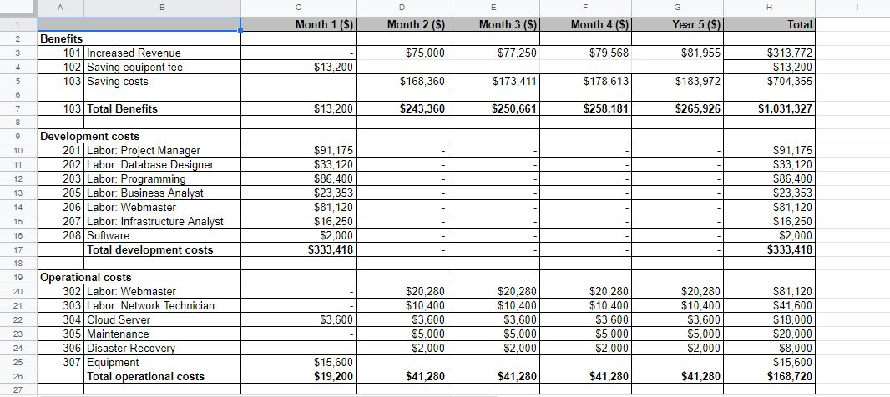



**Software Process:**

The software process chosen for this project is Agile Software development methodology. The Agile Software development is an approach to software development under which requirements and solutions evolve through the collaborative effort of numerous teams and their customers and end users. It advocates adaptive planning, evolutionary development, empirical knowledge and continual improvement and is developer centric. The main focus of this process is rapid delivery of software, since it allows different stakeholders to give their valuable feedback and suggestions for any changes to be made and these changes are incorporated  in the next phase of development.

**Justification for software process:**

Agile Software development is chosen for this project since it contributes to flexible changing requirements during life cycles of the project. The agile method satisfies numerous criteria such as:

* Communication between the client and the customer is face to face and changes are repeatedly recorded in phases between the developers.
* Accommodating changing requirements is flexible through measuring and evaluating the status of the project.
* It helps to build the correct product by delivering the accurate advice to the developers.
* Constant attention to technical excellence and good design enhances agility.
* Agile methods promote development that is sustainable, which suggests that the present needs are preserved for the future as well.

**Gantt Chart**

This describes the tasks to be completed and duration of each task using Graphical Notations.

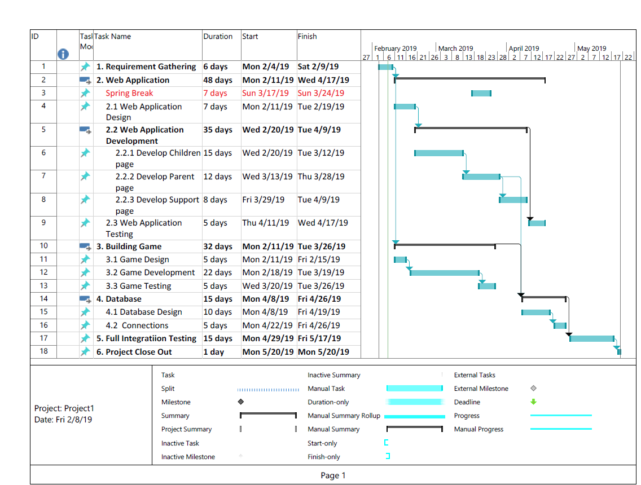

**Work breakdown Structure**

This describes the deliverable oriented hierarchical decomposition of the Project.

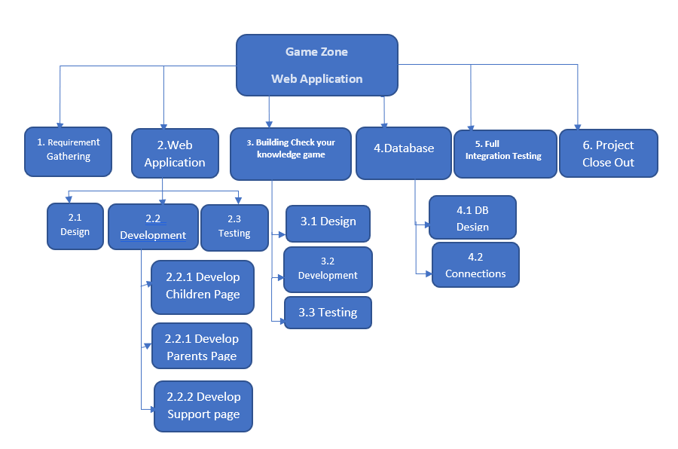

**Change Management Plan**

The need for change in the project is identified because some event may arise during the stages of project. For any change to be implemented following process should be followed:

Change generated: The need of the change is considered seriously if it has the positive impact on the project and benefits the customer. The change can be initiated by customer or project manager and team.

Change Proposal: Once a change is considered to have impact on the project, it is put forward to all the team members and customer in form of a document. The document explains the how the change gives positive impact on the project and how it benefits the customer.

Review: Once the change proposal has officially been put forward to customer, it is reviewed thoroughly.

Change Approval: This change approval must be signed by the customer and project manager. Once a change has been approved, before implementation the change is officially added to existing project plan.

Implement: In the implementation phase the changes are integrated into the system.